**535/3**

**PHYSICS**

**Paper 3**

**Jul./Aug. 2019**

**2 ¼ Hours**



**UTEB JOINT MOCK EXAMINATIONS, 2019**

**Uganda Certificate of Education**

PHYSICS

**Paper 3**

2 hours 15 minutes

**INSTRUCTIONS TO CANDIDATES:**

* Answer Question **1** and **one** other question. You will **not** be allowed to start working with the apparatus for the first quarter of an hour.
* Marks are given mainly for a clear record of the observations actually made, for their suitability and accuracy, and for the use made of them.
* Candidates are reminded to record their observations as soon as they are made.
* Whenever possible, candidates should put their observations and calculations in a suitable table drawn in advance.
* An account of the method of carrying out the experiment is not required.
* Squared papers are provided.
* Mathematical tables, slide rules and silent non-programmable calculators may be used.

**Turn Over**

1. In this experiment you will determine the relative density of **paraffin** provided.

**(30 marks)**

1. Clamp the metre rule vertically.
2. Suspend the spring with a pointer on the clamp besides the metre rule.
3. Suspend a beaker from the spring using a thread as shown in the figure 1 below.

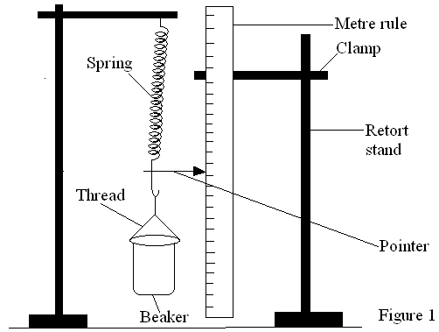

1. Record the initial position $p_{0}$ of the pointer on the metre rule.
2. Pour ${50cm}^{3}$ of water into the beaker and record the new position $p_{1}$ of the pointer.
3. Find the extension $y=p_{1}-p_{0}$ produced and record your results in a suitable table.
4. Repeat procedures (e) to (f) for ${100cm}^{3}, {150cm}^{3}, {200cm}^{3}$ and ${250cm}^{3}$ of water.
5. Remove the beaker, empty and dry it.
6. Repeat procedures (c) to (g) for ${{50cm}^{3},100cm}^{3}, {150cm}^{3}, {200cm}^{3}$ and ${250cm}^{3}$ of paraffin.
7. Find the extension $x=p_{2}-p_{0}$ produced in each case in step (i) and record your results in a suitable table.
8. Plot a graph of $y$ against $x$.
9. Determine the slope $s$ of the graph.
10. Determine the relative density of paraffin given that:

Relative density of paraffin $=\frac{1}{S}$

1. In this experiment you will determine the refractive index, n, of the glass slab.
2. Fix the plain sheet of paper provided onto the soft-board.
3. Place the slab on the sheet of paper with its largest face facing you.
4. Trace the outline of the slab and then remove it.
5. Draw a line **AB** (**B** marked about 2cm from **Q**) making an angle of 600 with **QT**.
6. Fix two pins **P1** and **P2** vertically on AB.
7. Draw a line MN parallel to RS at a distance , X=1.0cm.
8. Replace the slab and place mirror with its reflecting face facing RS on MN as shown below.

**x**

**M**

**N**

**R**

**S**

**t**

**B**

**600**

**P3**

**y**

**C**

**Q**

**T**

**P1**

**P4**

**P2**

**A**

1. Looking through the face **QT** of the slab, fix two pins **P3** and **P4**so that they appear to be in line with the image of **P1** and **P2**.
2. Remove the slab and the mirror and draw a line through **P3** and **P4** to meet QT at **C**.
3. Measure the length, y**,** of **BC**.
4. Repeat produces **(f)** and **(j)** for values of x= 1.5,2.0,2.5,3.0,3.5 and 4.0cm.
5. Tabulate your results including values of **xy**, and **I = ${4x}^{2}+ {3y}^{2}$.**
6. Plot a graph of **I** against **xy**.
7. Find the **I**-intercept, **c,** of the graph.
8. Measure thickness, **t,** of the slab.
9. Calculate the refractive index ,**n**, of the material of the slab from the expression, $n= \sqrt{\left(\frac{{3t}^{2}}{c}+ \frac{1}{4}\right)}$

**NB: Hand in your tracing paper together with the rest of your work.**

1. In this experiment, you will determine the internal resistance of the dry cell provided.  **(30 marks)**
2. Connect the circuit shown in figure **3**.

*V*

Fig**. 3**

*K*

1. Close switch, K .
2. Read and record the voltmeter reading, E.
3. Disconnect the circuit and connect the circuit shown in figure **4**, with $l_{o}=1.00 m$.

$l_{o}$ =1.00 m

Fig**. 4**

*K*

*V*

*l*

*Crocodile clip*

*Cellotape*

*Crocodile clip*

*Cellotape*

*Crocodile clip*

1. Starting with length, $l=0.100 m$, close switch *k*.
2. Read and record the voltmeter reading V.
3. Open switch,*K.*
4. Repeat the procedures (e) to (g) for values of $l=0.200, 0.300, 0.400, 0.500,$ $0.600$ and $0.700 m.$
5. Record your results in a suitable table.
6. Plot a graph of $V$ against $l$.
7. Find the slope, s, of the graph.
8. Calculate the internal resistance, $r$, of the cell from the expression

$$r=3.7\left(\frac{E}{s}-l_{o}\right)$$